Project Outline – Augmented Reality Training Tool

Project Overview

The purpose of this project is to develop an augmented reality tool that aims at training labor force to be familiar with a mechanical device (an air impact wrench in this case) without suffering from RSI (repetitive strain injury). This mechanical device may lead to RSI because frequent shock and vibration, if a person uses it regularly, and we plan to use AR technologies to train labor force to use the device without really touching it. We try to emulate a 3D model of this tool in a pair of smart glasses. This model can be controlled to implement all kinds of functions in the virtual environment like in the real-world environment, by general HCI devices (such as keyboard, mouse and so on), which are connected to the glasses. Therefore, this AR tool can help eliminate RSI, while still keep a high fidelity of the target device when training labor force.

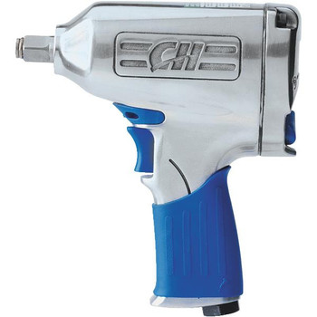Device Specs (Campbell Hausfeld TL050201AV):

* Torque: 250 ft. lbs.
* Revolutions / Minute: 10000 RPM
* Style: Pneumatic
* Air Flow: Requires 6.2 CFM @ 90 PSI
* Component: Metal
* Included: Impact Wrench,

Flip Socket (13/16" & 3/4")

3" Extension

1/4" NPT Air Inlet

Case

* Model: TL050201AV
* Length: 8 3/10" (21.08 cm)
* Width: 3" (7.62 cm)

Hardware Tools

1. PC.
2. Moverio BT-200.

Software Tools

1. Unity.
2. 3D model maker (such as Maya, Blender, Cheetah 3D and so on).

Major Tasks

1. Build the 3D models of the target device (Campbell Hausfeld TL050201AV) in a mainstream 3D model maker, which can be imported into Unity.
2. Design the control logic of the model of the mechanical device in the virtual environment. In other words, we have to determine which control module in HCI devices controls the implementation of a function of the 3D model as well as the viewing angle of it.
   1. Control module in HCI devices: Such as a button in a keyboard;
   2. Functions of the 3D model: such as the rotation of the drill, the movement of a button and so on;
   3. Viewing angle: the different angles for the users to observe the 3D model in the virtual environment.
3. Implement the above-mentioned control logic as well as the visual and auditory feedback of the 3D model.
   1. Visual feedbacks: For example, the drill of the 3D device rotates, which can be seen in the virtual environment.
   2. Auditory feedback: For example, when we see the drill of the 3D device rotates, we can also hear corresponding voice about it.
4. Transplant the above-mentioned AR tool, which is built in PC, into Moverio BT-200.
5. Recursive testing and modifying the design and implementation.

*\*Further steps will be added if any additional functions are required.*

Division of Task

Due to the fact that these tasks cannot be done in parallel (for example, before programming the control logic of the 3D model in Unity, the model should have been built with a 3D model maker), each of us will take part in each task, which also allows us to gain enough experience of all aspects of the project.

1. Guofan and Richard are separately responsible for building different parts of the 3D model in the same 3D model maker.
2. Guofan and Richard will discuss about the design of the control logic and come up with an optimal plan together.
3. Guofan and Richard are separately responsible for coding different parts of the control logic in C# within Unity, as well as different parts of the visual and auditory feedback.
4. Guofan is responsible for this, and Richard will examine the effectiveness.
5. Guofan and Richard will test the AR training tool together, as well as optimize the original design and implementation.

*\*More details will be added as the project proceeds.*

*\*Further steps will be added if any additional functions are required.*

Scheduling

Meetings among Prof. Cooperstock, Guofan and Richard: At least one time / two weeks

Meetings between Richard and Guofan: At least three times / week